**Iot based plant watering system**

**Introduction**

For the automatic plant watering system, a moisture level sensor is attached to the soil of the plant and when the reading of the sensor is below the pre-set value, the pump will be activated

The second component is an Arduino Nano, which takes readings from DHT11 and displays on an OLED

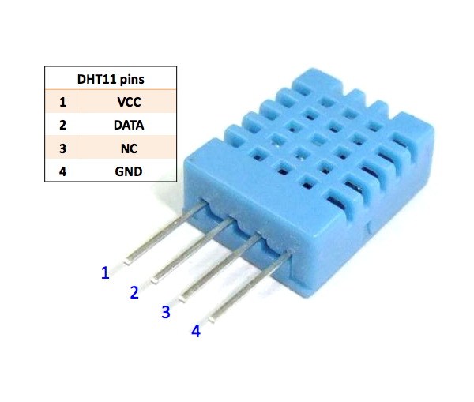

**Components**

* ESP-01 node MCU Module
* DHT11temperatureandhumiditysensor Module
* Water Pump Module
* Relay Module
* OLED display
* Connecting Wires

Application

This sensor is used in various applications such as measuring humidity and temperature values in heating, ventilation and air conditioning systems. Weather stations also use these sensors to predict weather conditions.  The humidity sensor is used as a preventive measure in homes where people are affected by humidity.  Offices, cars, museums, greenhouses and industries use this sensor for measuring humidity values and as a safety measure.

Objective

During this activity ,you will help students to achieve following objectives

1. Understanding the principle and operation of DHT-11 temperature and humidity sensor
2. Design algorithm and flowchart to on motor to water plants
3. Programming DHT-11 temperature and humidity module using Arduino nano
4. Interfacing DHT-11 temperature and humidity module with Arduino nano

Flowchart

Program

#include <Wire.h>

#include <Adafruit_GFX.h>

#include <Adafruit_SSD1306.h>

#include <DHT.h>

#define DHTPIN 2 // what pin we're connected to

#define DHTTYPE DHT11 // DHT 11

#define OLED_RESET 4

Adafruit_SSD1306 display(OLED_RESET);

// Initialize DHT sensor for normal 16mhz Arduino

DHT dht(DHTPIN, DHTTYPE);

String info;

boolean watering= false, status=false;

void setup()

{

Wire.begin();

dht.begin(); // initialize dht

display.begin(SSD1306_SWITCHCAPVCC, 0x3C);// initialize with the I2C addr 0x3C (for the 128x32)(initializing the display)

Serial.begin(9600);

}

void displayTempHumid(){

delay(2000);

// Reading temperature or humidity takes about 250 milliseconds!

// Sensor readings may also be up to 2 seconds 'old' (its a very slow sensor)

float h = dht.readHumidity();

// Read temperature as Celsius

float t = dht.readTemperature();

// Read temperature as Fahrenheit

float f = dht.readTemperature(true);

// Check if any reads failed and exit early (to try again).

if (isnan(h) || isnan(t) || isnan(f)) {

display.clearDisplay(); // clearing the display

display.setTextColor(WHITE); //setting the color

display.setTextSize(1); //set the font size

display.setCursor(5,0); //set the cursor coordinates

display.print("Failed to read from DHT sensor!");

return;

}

display.clearDisplay();

display.setTextColor(WHITE);

display.setTextSize(1);

display.setCursor(0,0);

display.print("Humidity: ");

display.print(h);

display.print(" %\t");

display.setCursor(0,10);

display.print("Temperature: ");

display.print(t);

display.print(" C");

display.setCursor(0,20);

display.print("Temperature: ");

display.print(f);

display.print(" F");

}

void loop()

{

displayTempHumid();

display.display();

}

Hardware

1. connect DHT11 sensor module VCC and GND pin to Arduino nano 5 voltage pin and round pin and connect signal pin of sensor to Arduino A7 pin .
2. connect OLED display VCC and ground connection to Arduino nano board and SCL (serial clock pin ) to A5 and SDA(serial data)pin to A4.
3. Connect relay module VCC and GND pin Arduino board and signal pin ESP-01 module pin 3.output pin of realy is given to pump to start water.
4. Connect VCC and Pin $ (CH-PD) pin of ESP-0 module to D12 pin of Arduino nano board

